“The G-O-A-T Domain” yes, the name of my site I have decided to create for this assessment. The entire premise of the creation of this site was to work on something you find fun and interesting. In any case basic website creation is in and of itself already interesting in my opinion. However, I have decided to combine this with one of my favorite sports and hobbies, basketball. Essentially, I intend for this site to be a fun (initially small) basketball area/space where various functions can take place such as game score calculation, overall calculation, basic basketball information, trivia and of course player information (which is the fore-front feature of the site).

**Sites associated with this assignment:**

NBA.com – This is the official site for NBA Basketball (the biggest basketball league in the world) this site contains a lot of information when it pertains to players and their information. The main menu for this page is laid out at the top of the page horizontally with various links to information on the website (such as latest news, information interesting content and etc.) listed to the right hand side of the page in an article and section class, as well as a footer which contains links to sister websites, co-owned websites, social media pages and policy and conditions, the site also carries a very basic black and white theme which is not very appealing on its own but considering the site’s usage of images and video this comes off as very clean and satisfying. This is a theme which runs throughout the website. What we are looking at mostly from this site is its player data and its layout of player information. However, there is something to be said about its neat setup (this of course should be expected from a site which is perpetually updated and run on a daily basis by multiple individuals).

Basketball-Reference.com – Arguably the second most famous site when to comes to basketball-reference takes what the NBA official website has in terms of historical basketball Statistics and Data and expands on it going it more detailed stats categories. Albeit less aesthetically pleasing of a website and noticeably more primitive and rougher with its layout and upkeep, the information on this site is undoubtedly invaluable to this project and will be integrated into our website as much as possible. This website is HTML as compared to NBA.com which is more akin to HTML5, and it really shows. The layout of this page sees an equally complex navigational bar laid out horizontally at the top of the page with a moveable flex box on some pages on the site which links back to the top of the page. The area in which this differs from our first listed site is (apart from HTML versions) the footer which contains two sections split parallel to one another which links to other site pages, social media pages and copyright information. then followed by another comprehensive underneath containing policies and terms of conditions. What we are looking at mostly from this site is its in-depth data and layout of said data in table format. There is something to be said about how information in these tables links to other pages containing other tables sort of in a database format, however, I do find the sites overall layout to be a bit clunky and tedious on the eyes even though it is not very complex to understand.

Chat.openai.com (ChatGPT) – Use of ai can be a very controversial matter when it comes to creating a report. However, it does have its uses. Our list of 25 players for this project was taken from ChatGPT as formulating a list of your own can be very subjective also, each site and individual has their own opinion on the matter. This is where ai plays a role as it compiles multiple sources of information and inspects it to give as accurate of an estimate as possible. Given that ChatGPT played a very minuscule role in this project it would not be surprising to see many leave any mention of the site out. I do, however, believe there is something to be said about the site and its simplicity yet elegance and underlying functionality. This is a one-page site with two main sections being the presentation/interaction area which is the main part of the page and a side bar/menu which is a storage unit of sort for your account, settings, and previous entries into the interactive area. One thing which really caught my eye about ChatGPT is that it creates HTML on the fly without problem and in such a brief time as well, playing around with it to see how it formatted and structured HTML was remarkably interesting. It truly is a technological novelty in my eyes.

YouTube.com – There is not much of an introduction needed for a site such as YouTube as it is one of the most famous and traffic heavy sites in the present day. YouTube is the biggest video database in the world and has played a part in the creation of many sites whether it be by sharing information or being integrated into the site itself. In this project we use YouTube for the latter as it contains a highlight package for every player as well as additional basketball information. Probably the first and only site used here with a significantly different mobile and desktop page layout, YouTube’s layout is straightforward with a header with a search bar, site settings, account information and a dropdown menu. The video playback main page changes this a bit with an additional section containing recommended videos. This coupled with a navigational sidebar to the top left-hand side of the page give the website a very minimalistic feel, which in this case is not a terrible thing. The biggest surprise to me was the lack of HTML5 used in the site.

Omnicalculator.com - OmniCalculator is a site based around calculators and calculations, seeing how we can implement math into our daily lives to make things more accurate and easier to solve using math. The page layout is very sleek and smooth with a flex box navigational bar which is ever present the top of the page and a quite simple footer containing links to other calculators located on the site, more information on the page and its creators as well as social media information, the site is laid out neatly on top of its black, white and purple or blue theme depending on what page you are on. What we are most interested in is the pages calculations and java script functionality, it does in fact have a few basketball calculators which tie in quite well with our project, so it is safe to say that more than a few things can be learned from this site.

Sporcle.com - Sporcle is an online website dedicated to trivia and quizzes and is where we will look for our trivia aspect feature in our own site development. The site has a theme heavily focused around orange being incorporated with the standard black and white layout. The site has a navigation bar within the header and an additional bar for navigation, which is not as present as the one in the header. The body of the main page is split into two parts, the right columns house links to additional quizzes and pages within the site whilst the left column is host to the main interactivity, with a footer containing additional information about the site, site settings, policies, and social media links. The other pages, however, have one main body. The main modus of operandi the site takes with its quizzes is hiding the answer until the user types it in correctly. This is the approach we aim to take with our own quiz format also.

**Features of the site**

There are five primary features we aim to implement in the creations of this site. Each is listed below along with any further information.

* Player Database – This will be a page containing a list of each player and their career stats to date. These stats will be the very base set of stats which include position games played, minutes, points, assists, rebounds, field goal percentage, 3pt field goal percentage, rebounds, steals, blocks, turnovers. Additionally, each player's name should link back to their individual page on our site where more information is given in depth about said player. Our site is based around basketball, and everything to do with it. One of the biggest talking points of this sport is always who is the greatest to ever play, hence why this in my opinion is the building block of our site.
* Player Page – This is where each player is explored more in-depth than just their statistics. Up front and center will be a picture of the player also, more information about the player will be given such as a short paragraph giving the user a slightly deeper look into the player as well as the player’s highlight package which will be acquired from YouTube, this will give the user a better view on the player when trying to understand the player’s style as statistics alone do not tell the full story when it comes to any sport.
* Basketball School – Basketball school is the title I have given to the part of this assignment where we elaborate on the sport a bit more and share knowledge of the sport. The planned layout is one where we have a brief introduction on the sports creation, some of the general rules of the sport, the types of game modes/the ways in which the sport can be played, and of course different terminology used in the sport accompanied by visual depiction (whether that be photo or video). It is important to have such a feature particularly because we cannot guarantee that everyone who comes across our site has in-depth knowledge about basketball or even knows the bare minimum. Even with that many individuals may be extremely familiar with the sport but not with its terminology and various arguments when it comes to the enforcement of the rules.
* Player Calculator – in this part of the project we are aiming to create different calculators related to the sport, one being a Game-Score (GS) calculator which summarizes a player’s performance during a game into a singular representative number/rating, there is also an Effective-Field-Goal% (Efg%) calculator which we will use to measure how efficient a player is when attempting to score and finally our very own player overall calculator where, taking in to factor various statistics and factors we attempt to create an overall rating number for a player. It is always nice to have things summarized. It gives an even better feeling when taking raw figures and packaging them neatly into concise and comprehensible figures. The aim of our first two calculators. The final calculator on the other hand is a thing of fantasy. Players love recognition for their ability and love comparing themselves with one another in the sake of competition having a way to compact all those different areas of the sport into a singular rating surely would be a delight for anyone who is into the thought of placing themselves up against their teammates in terms of perceived ability.
* Basketball Trivia – finally we arrive at our last major feature which is our trivia page. This is where we inject a bit more fun into the page. Yes, numbers in the right way can be exciting but we would also like to give the user a bit more interactivity so having a trivia page is out go to method in this case. As stated above, our form of trivia is for the user to submit their answers and if correct then that card will be revealed if not then no actions will take place. Ideally, we would like to have both general and player specific trivia, this task would ideally be a bit difficult considering time constraints.

**Website Outline**

Illustrated below is a visual representation of how we intend to organize our website pages.

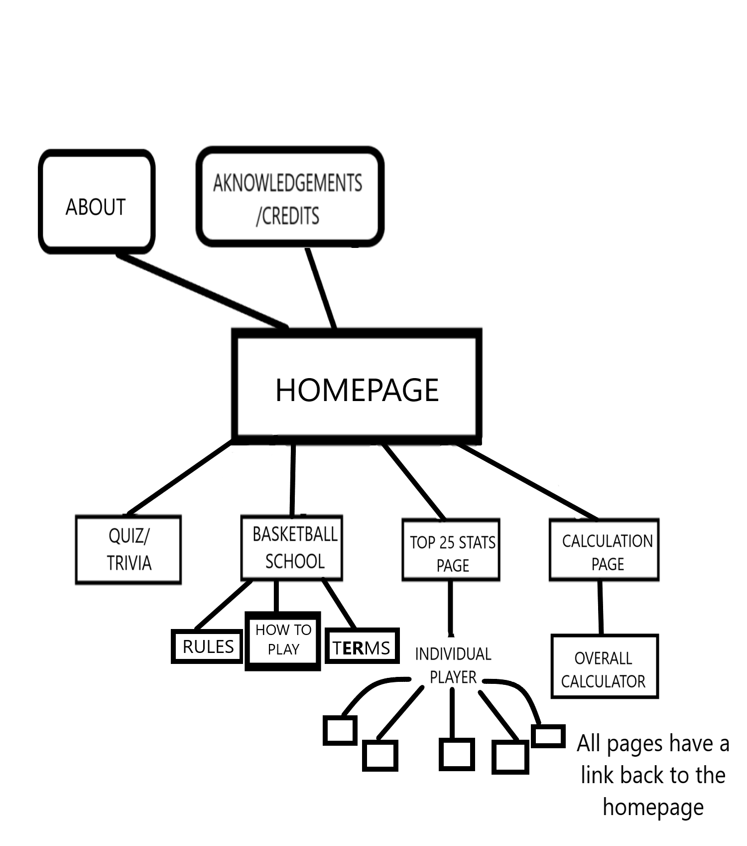

As seen above, this is our expected website tree structure. We plan to have the homepage link to almost everything instead of putting a feature immediately front and center of our page as our homepage. Four of our main pages flow down straight from our homepage however, our individual player pages are links from the top 25 player page. This, I find is easier to follow as it flows more logically from the top 25 player page, and this prevents cluttering the homepage in a clunky manner. The overall calculator page deserves its own page in my opinion as it is slightly different from our other two calculators and is a much more ambitious endeavor than our other two calculators the presentation of this page will be a bit more grandiose as it is tied closer to fun over anything else. With the basketball school feature from the main page, we have decided to split the information given here into three parts, this is because it is easier to digest the information this way and easier to find information on exactly what the user main be looking for instead of endlessly having to comb through one page. In addition, we have included an about us page and an acknowledgements page which will contain external links to related or useful sites. Each page will have a way to return to our homepage, this will be through a navigation bar and the top of the page.

**User Interface Sketch**

Below is an image of how we plan for our webpage to look initially in terms of user interface.

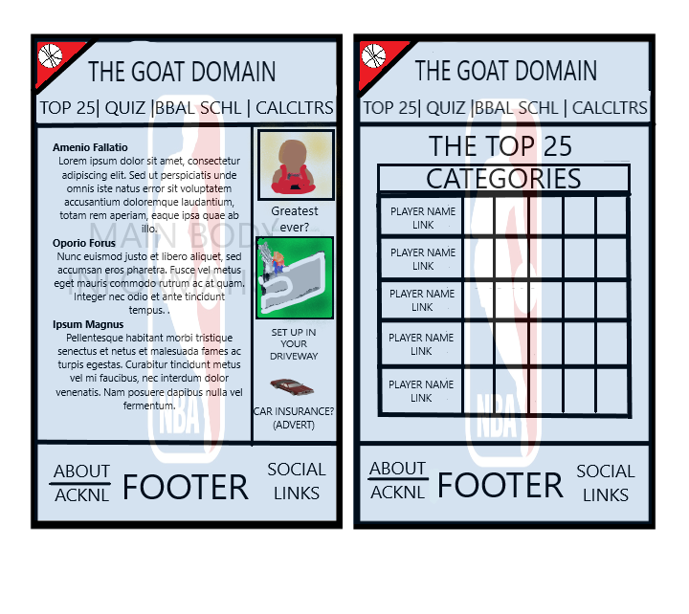

The images above are a rough depiction of how we intend for the site interface to look. The image to the left is our main page/homepage which we plan to be slightly different from the rest of our pages. It is split up into two sections, one being the main body which will elaborate on what our website is about and what its pages are about and talk some basketball. Ideally, we would also like it to contain the latest basketball news and links to articles and external pages containing more information about said news. The other section of our main page is an area for potential ads, links to other areas on our site randomly generated. We would like this to be an eye-catching area of our page where the user would be interested in delving deeper into our site. On the left is the layout of our page we will run into more often with a standard navigational bar, main body housing all our interactivity and a footer. The page background is that of the NBA logo shaded in blue to give a faint feel of color to the page. We want to incorporate the colors blue and red into the page subtly but also having it be apparent that it is part of the theme. This design was inspired by a few of the sites we investigated earlier but mainly NBA.com and the way it lays out the information on its homepage, and sporcle and the way they incorporated orange into their theme.

**Organizing/ Managing Time**

Time waits for no one, or all things must come to an end, two quite common phrases denoting that there is always a deadline. With that said, having a plan is always a strong strategy to combat and counteract time and deadline. We have 8 weeks (about 2 months) of times between now (March 1st, 2024) and our due date

My day-to-day life is one quite filled and bustling. I currently work a full-time job Monday to Wednesday 8am to 5pm, Thursdays 8am to 4pm, Fridays 8am to 3pm and 7am to 2pm every other Saturday. Sunday is my only guaranteed day of complete freedom bar going to church. In addition to that time and effort must be split between two courses/project being Web Technology and Software Development. Software development requires group meeting for completion of a project for an hour to two hours every Tuesdays and Thursday starting at 8pm and 3pm every Sunday. It usually takes me half an hour to get from work to home so any work we plan to go through with on our website can truly begin an hour after my shift has ended.

The plan is to work with the gaps. Mondays, Wednesdays, and Fridays after work are truly crucial days in the week for our progress as they are devoid of any mandatory after work duties, Saturdays are somewhat of a jackpot this is where we get the bulk of our time, and finally Sundays are due to my beliefs a day of rest. Bringing all that into consideration our plan is to blitz our project on the three open weekdays and split our time on Saturday between our two projects.

Our first focus is to build our pages first, HTML and CSS after we test and tweak. Then when that is completed, work on any required JavaScript functionality test and tweak. Our last step is to build in the connectivity and organize our pages properly into a functioning website. This is the plan we aim to loosely follow. It is to be said and taken into thought however that circumstances can change, and we must prepare for any situation where we face difficulties, and we must respond to them in a timely manner, we have built a cut-off point into our project for each stage of work in the event that a process is taking too long to ensure that we are able to put out an operational website when all is said and done despite any challenges.

Below is a data table of how we plan to organize our time in the coming weeks:

|  |  |  |  |  |  |  |  |  |
| --- | --- | --- | --- | --- | --- | --- | --- | --- |
| TIME | SUNDAY | MONDAY | TUESDAY | WEDNESDAY | THURSDAY | FRIDAY | SATURDAY | ALTERNATE SATURDAY |
| 8AM | REST | WORK | WORK | WORK | WORK | WORK | WORK/REST | REST |
| 9AM | REST | WORK | WORK | WORK | WORK | WORK | WORK/REST | REST |
| 10AM | REST | WORK | WORK | WORK | WORK | WORK | WORK/REST | REST |
| 11AM | REST | WORK | WORK | WORK | WORK | WORK | WORK/REST | REST |
| 12PM | REST | WORK | WORK | WORK | WORK | WORK | WORK/REST | REST |
| 1PM | REST | WORK | WORK | WORK | WORK | WORK | WORK/REST | WEB TECH/SOFT DEV |
| 2PM | REST | WORK | WORK | WORK | WORK | WORK | WORK/REST | WEB TECH/SOFT DEV |
| 3PM | REST | WORK | WORK | WORK | WORK | WORK | PREP | WEB TECH/SOFT DEV |
| 4PM | REST | WORK | WORK | WORK | WORK | PREP | WEB TECH/SOFT DEV | WEB TECH/SOFT DEV |
| 5PM | REST | WORK | WORK | WORK | PREP | WEB TECH | WEB TECH/SOFT DEV | WEB TECH/SOFT DEV |
| 6PM | REST | PREP | PREP | PREP | SOFT DEV | WEB TECH | WEB TECH/SOFT DEV | WEB TECH/SOFT DEV |
| 7PM | REST | WEB TECH | SOFT DEV | WEB TECH | SOFT DEV | WEB TECH | WEB TECH/SOFT DEV | WEB TECH/SOFT DEV |
| 8PM | REST | WEB TECH | SOFT DEV | WEB TECH | MEETING | WEB TECH | WEB TECH/SOFT DEV | WEB TECH/SOFT DEV |
| 9PM | REST | WEB TECH | MEETING | WEB TECH | MEETING | WEB TECH | WEB TECH/SOFT DEV | WEB TECH/SOFT DEV |
| 10PM | REST | WEB TECH | MEETING | WEB TECH | SOFT DEV | WEB TECH | WEB TECH/SOFT DEV | WEB TECH/SOFT DEV |
| 11PM | REST | REST | REST | REST | REST | REST | REST | REST |
| 12AM | REST | REST | REST | REST | REST | REST | REST | REST |
|  |  |  |  |  |  |  |  |  |
| PERIOD | TASK | DURATION | COMPLETION | |  |  |  |  |
| WEEK 1 | DESIGN | 19 HRS | 33% | |  |  |  |  |
| WEEK 2 | DESIGN | 17 1/2 HRS | 66% | |  |  |  |  |
| WEEK 3 | DESIGN | 19 HRS | 100% | |  |  |  |  |
| WEEK 4 | DESIGN/JAVA | 17 1/2 HRS | 100/33% | |  |  |  |  |
| WEEK 5 | JAVA | 19 HRS | 66% | |  |  |  |  |
| WEEK 6 | JAVA | 17 1/2 HRS | 100% | |  |  |  |  |
| WEEK 7 | JAVA/TOUCH UP | 19 HRS | 100/50% | |  |  |  |  |
| WEEK 8 | TOUCH UP | 17 1/2 HRS | 100% | |  |  |  |  |

The task column is in order of what tasks we plan to work on and when we plan to move onto our next task with a bit of leeway between switchovers. The completion column is an estimate of where we are hoping to be by the very end of the week. If we are behind once the task is no longer listed under the task column, we cut it off and move onto our next task. If we do find time after we have fully completed our website and its functionality, we will then go back to any areas we need to touch up on with the site, hence the name of our final task. If we are ahead of time even better, we can in that case push on forward and look to implement new features or improve on what we already have as features.

**Additional Features**

For something to catch the eye in most cases it must stand out and with that thought in mind I aim to add customizability to each player database. I am looking into having a song play for certain players which describes them or is associated with them whenever the page is opened. Also, a theme/color scheme for each player according to the team they were most associated with or a mixture of teams they were associated with as well as a custom background image for the page.

For the overall rating calculator not only do we want to display an overall rating but according to a blend of all the figures placed into the calculator we would like to display not only an overall rating but also a play archetype or suited play style for player.

**Conclusion**

I would like to thank you dear reader for skimming through this report. I look forward to working on this project and I have learned many things thus far as someone who is fairly new in all senses to of the word to development. I do look forward to learning even more and hope that this project can leave an impression on those who come across it in the future. This is only the beginning of an exciting journey.